IMLS Public Library – Compare Public Libraries tool

The Institute of Museum and Library Services is responsible for reporting annually about public libraries in the US. State Libraries serve as the local data reporting agent, adding specific state questions to those adopted for the national data reporting.
Collection happens at the state level at the end of the library fiscal year – this varies in every state, and some states deal with multiple fiscal years.
The State Library edits the data, then reports it to IMLS. IMLS then reviews the data, imputes for missing values (item level non-response) to establish state and national estimates – per capita are the most typical that you might use.
The data are then reported in a Compare tool, as well as data sets and a narrative report with tables.
The demonstration and exercises today will focus on the Compare tool.
The Compare Public Libraries tool can be found searching the site, or following various navigation streams:
- Research/data collection
- Research/data analysis tools

Exercise
- Go to www.imls.gov
- Click on “Research”
- Click on “Data Analysis Tools” Click on “Library Services”
OR
- Click on “Data Collection” Click on “Public Library Survey”
- From either page, Click on “ Compare Public Libraries”
- Click on “Begin”
- Complete “Library of Interest” search form for your library – this is YOUR library
- Click on the link to your library data for FY2013

SACRAMENTO PUBLIC LIBRARY
Public Libraries Data - FY 2013
Data are fiscal year, and are typically updated in June each year. FY2013 is the most current data available.
Changes after Fiscal Year 2013 will be updated in subsequent annual surveys. If information is incorrect or has changed, contact the State Data Coordinator (93KB) for the state where the library is located.
Click on the pie chart icon next to the category heading to view a pie chart for that category
Export this library data to an Excel file

FSCS ID:  CA0105 | Location Address:  828 I ST.  SACRAMENTO , CA 95814 | Mailing Address:  828 I ST.  SACRAMENTO , CA 95814
County:  SACRAMENTO | Phone Number:  (916)264-2770
Organizational Characteristics
Administrative Structure:  Administrative Entity with multiple direct service outlets where administrative offices are not separate | Meets FSCS Public Library Definition:  YES | Legal Basis:  Multi-jurisdictional
Interlibrary Relationship:  Member of a system, federation, or cooperative service, but not the headquarters | Number of Bookmobiles:  2 | Number of Branch Libraries:  27
Number of Central Libraries:  1 | Number of Outlets:  30 | Population of Legal Service Area:  1,373,512

Paid Full-Time Equivalent Staff (FTE)
ALA-MLS Librarians:  69.50 | Librarians without ALA-MLS:  2.00 | Total Librarians:  71.50
ALA-MLS Librarians As Percent of Total Staff:  26.7% | Other Staff:  188.50 | Total Staff:  260.00
Other Staff per 1,000 Population:
0.14

Exercise
- Review the summary data
- Click on the info links
- Find other per capita calculations
- Find other types of calculations (e.g., per 1,000)

Operating Revenue
Local Revenue:
$32,474,995
Operating Revenue
Local Revenue per Capita:  $23.64 | State Revenue:  $23,864 | State Revenue per Capita:  $0.02
Federal Revenue:  $86,596 | Federal Revenue per Capita:  $0.06 | Other Revenue:  $2,703,766
Other Revenue per Capita:  $1.97 | Total Revenue:  $35,289,221 | Total Revenue per Capita:  $25.69

Exercise
- Exit the summary display for your library and return to Select Your Library of Interest
- Click the button next to your library, click on Begin
- Click on Choose Similar Libraries (Comparison Group) By Variable
- Explore the categories by clicking on the + (plus symbol) next to each

Exercise
- Select only ONE variable from the list. Common variables against which to compare your library with others include:
  - Population served
  - Number of branches
  - Circulation
  - Staff FTE

Below is an example of the variable Population of Legal Service Area for Sacramento Public Library.
There are two methods presented for finding similar libraries based on this variable - Method 1 is a percentage range (plus or minus) – you can determine the percentage range. The default is 20%.

Exercise
- Select Method 1 at 20% range
- Click Continue
- Explore the library comparison results

20% of Sacramento PL population of legal service area produced 14 libraries to compare against.

Exercise
- Click on the number of peer libraries in your search to explore the libraries found based on the variable searched against.

Looking at the peer group – you can click on the hyperlink for any library and see a similar summary as you saw earlier for Sacramento.

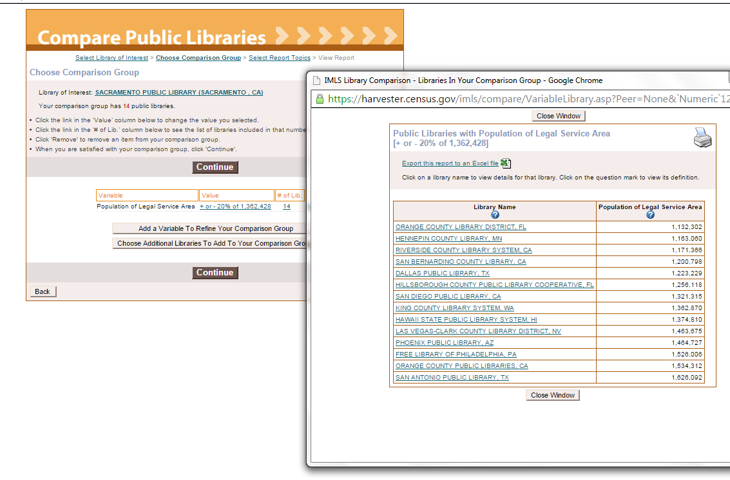
You can add variables to reduce the size of the peer group. 14 is a small enough group, so not additional variables are needed.

Discussion (10 mins)
- Identify 2-3 data points from the IMLS results that are valuable to your planning and record in your journal.
- Discuss with your table group why these data points are particularly important to your planning.
- Discuss how you will use these data if future planning.

More Skills to Learn Later

Continuing from the step of identifying a peer group within 20% of a characteristic you determined (e.g., population of legal service area, total circulation, expenditures, etc.), follow through the next exercises to run a report and become more familiar with the data for export.

Exercise
- No changes to the comparison group, click on Continue
- Select Report Topics – this allows you to identify up to 7 (seven) characteristics at a time to build a comparison table for all the libraries in your peer group.
- Explore each of the characteristic areas. Each has an information link
- Select up to 7 characteristics – do NOT select the original variable (population of service area, etc.)
- Click on Continue to run the report

It is possible to save the search you completed, and export the search in various file formats. Within the report as presented through the Compare tool, it is possible to view graphical displays of the data you selected. Click on the graphic icon in each column.

Exercise
- Explore the data for each library in the peer group
- Explore saving as an Excel file
- Explore Save Comparison Report
- Click on the graphic display options for the data – if more than 12 libraries in the peer group the graphic displays will not work – also require Adobe Flash

Review

- Search your library first
- Select a variable to compare your library with others
- Select a method to develop a range against which peer libraries are identified
- Explore the peer libraries
- Reduce the peer group size by adding variables or by decreasing the percent range for comparison
- Select topics (characteristics) to develop a peer comparison report
- Review the report, refine by removing characteristics or libraries
- Save the report as an Excel or on the IMLS website

Questions
- How will you use these data for planning?
- Are the annual data sufficient for comparison?
- Were you able to develop a reliable peer group that you will use into the future?

