Rio Linda

Rio Linda Library recently moved to the site of the former Rio Linda Elementary School. This beautifully renovated building offers modern technology in a very welcoming, cozy setting. There are comfortable armchairs in each area of the library, and plenty of tables and chairs for reading, studying, and hanging out.
The children’s area offers toys, puppets, and a small puppet theatre for the children, donated by the active Friends group. Windows look out over a playground and softball field. Entrance to the large parking lot is from 6th Street. The first library in Rio Linda opened on September 26, 1916. Our centennial is just around the corner!
The Rio Linda library book store is managed by the Friends of the Rio Linda Library and proceeds from the non-profit store will be used to support the children’s and adult programs at the Rio Linda library.

631 L St.

Rio Linda, CA 95673

Nearest Cross Street: Corner of 6th Street and M Street, parking entrance on 6th Street.
Nearest Transit Stop: M St & 6th St (WB)

Hours:
Sunday: | Closed
Monday: | Closed
Tuesday: | 12 p.m. - 8 p.m.
Wednesday: | 10 a.m. - 6 p.m.
Thursday: | 10 a.m. - 6 p.m.
Friday: | 1 p.m. - 6 p.m.
Saturday: | 10 a.m. - 5 p.m.

Branch Amenities
- 7778 sq. ft. sq ft location
- Lobby book sale

Book Drop:
Located next to the entrance

Collection:
- 18,000

Computing & Workstations:
Reserve a computer
- 22 Internet & MS Workstations
- 1 Early Learning Workstations
- 4 Online Catalog Workstations
- Photocopier/Printer
- WiFi

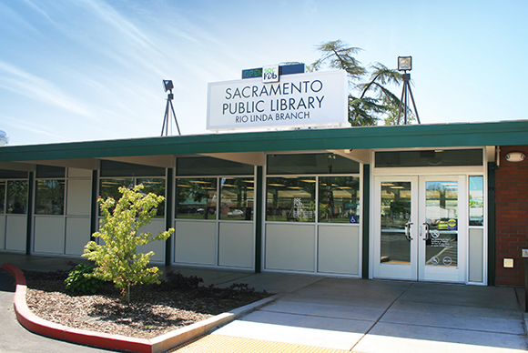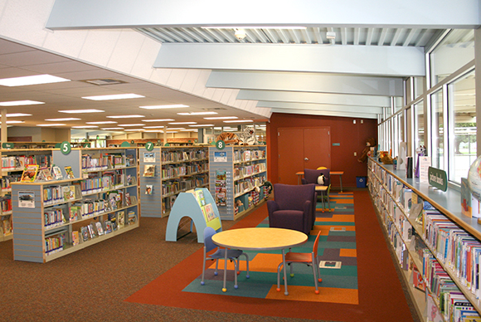
PrevNext

